**\*/ Ashok Rathod 9.9.2019/\***

**Manage Table Relationships**

Power BI Desktop has automatically detected and created table relationships. So the first step is to ensure all the relationships are properly created, and if not, create them yourselves.

1. Start with the " Section 2 – Lab .pbix" file.

(One Drive link - <https://1drv.ms/u/s!AgsRLppxitDjgQKIn2jRC9gmW2rw> )

1. Open the **Relationship** view.
2. Ensure that there is a many to one relationship with both cross directional filtering from the **ProductID**column on the **Sales** table to the **ProductID**column on the **Products**table. If not, create the relationship by dragging the **ProductID** column on the **Sales** table to the**ProductID** column on the **Products** table.
3. Ensure that there is a many to one relationship with both cross directional filtering from the **ManufacturerID**column on the **Products**table to the **ManufacturerID**column on the **Manufacturers**table. If not, create the relationship.
4. Ensure that there is a many to one relationship with both cross directional filtering from the **Date** column on the **Sales** table to the **Date** column on the **Date** table. If not, create the relationship.

Now you want to create a relationship between the **Sales** table and the **Locations** table. First, you merge the **Country** and **Zip** columns in both **Sales**and **Locations** table as a new column, **CountryZip**. Then, you create a relationship on the **CountryZip**column for both tables.

1. Edit the **Locations**table in the **Data** view.
2. Add a new column named  **CountryZip**by concatenating the value from the **Country** column, a “_”, and the value from the **Zip** column.
3. Edit the **Sales**table in the **Data** view.
4. Add a new column named  **CountryZip**by concatenating the value from the **Country Name** column, a “_”, and the value from the **Zip** column
5. Link the newly created **CountryZip**column on the **Sales** table to the newly created **CountryZip**column on the **Locations** table.

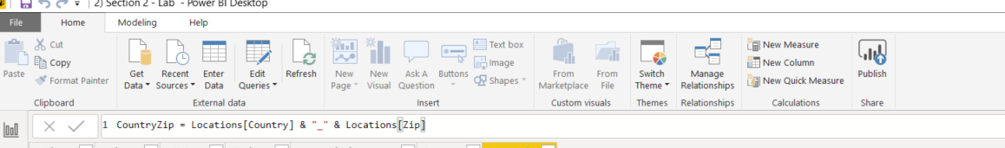

CountryZip column with dax

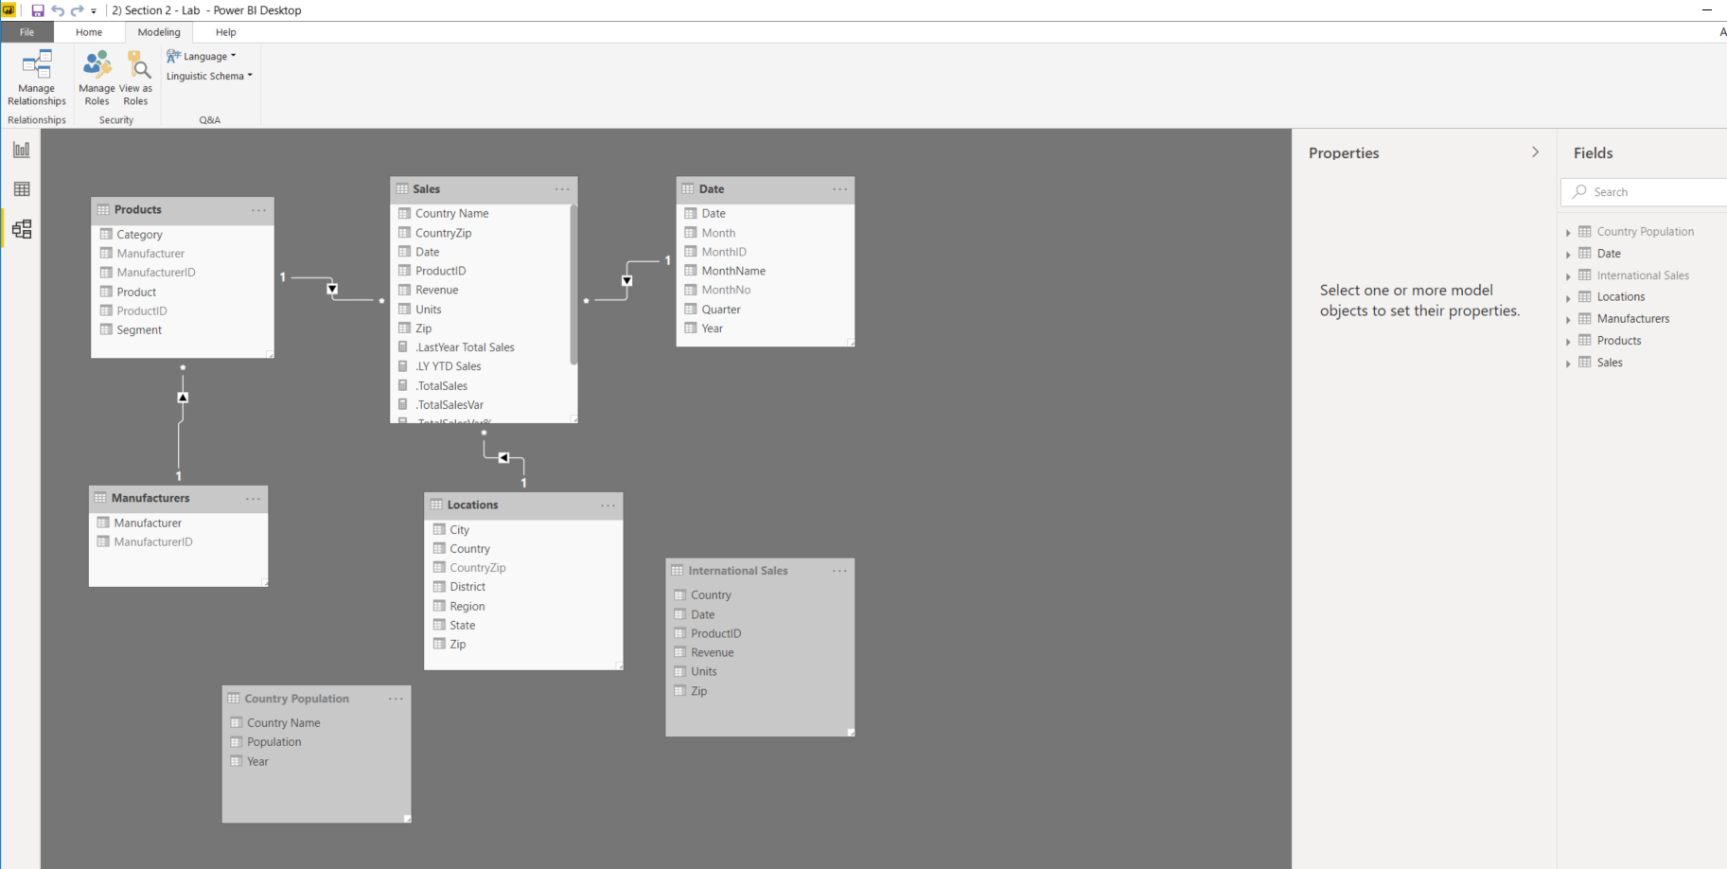

I have created relationship between tables.

**Last Year Comparison**

 You want to know how much sales (revenue) and compare this with the figure from the same period last year. You need to create several calculated measures to help with this comparison. To do so, in either the **Report** view or the **Data** view, right-click the**Sales** table, click **New Measure**, and type in the corresponding DAX formulas for the measure you want to create. This will create the measures with the **Home Table** properties set to the **Sales** table.

Specifically, you will create the following measures (screen shot of measures):

* **Total Sales**: calculates the total sales. Format this measure as **Currency**. (Hint: Check out the **SUM** function).
* **LY Sales**: calculates last year sales. Format this measure as **Currency**. (Hint: You might find the **CALCULATE** and **SAMEPERIODLASTYEAR** function useful).
* **Sales Var**: calculates sales variance between this year and last year sales. Format this measure as **Currency**. (Hint: This is simply the difference between **Total Sales** and **LY Sales**).
* **Sales Var %**: calculates sales variance between this year and last year sales in percentage. Format this measure as **Percentage**. (Hint: This is simply the percentage of **Sales Var** from **LY Sales**. You might find the **DIVIDE** function useful).

If you're stuck, check out the following DAX expressions to calculate similar measures, but on **Units** instead of **Revenue**.

* **Total Units**: Total Units = SUM(Sales[Units])
* **LY Total Units:** LY Total Units = CALCULATE([Total Units],SAMEPERIODLASTYEAR('Date'[Date])
* **Total Units Var**: Total Units Var = [Total Units] - [LY Total Units]
* **Total Units Var %**: Total Units Var % = DIVIDE([Total Units Var],[LY Total Units])

|  |
| --- |
| * .LastYear Total Sales = CALCULATE([.TotalSales],SAMEPERIODLASTYEAR('Date'[Date])) * .TotalSales = SUM(Sales[Revenue]) * .TotalSalesVar = [.TotalSales] - [.LastYear Total Sales] * .TotalSalesVar% = DIVIDE([.TotalSalesVar],[.LastYear Total Sales]) |
|  |

Above table shows the DAX code for different measures

**Year to Date**

Year-to-date (YTD) is a period starting from the beginning of the current year and continuing up to the present date. You want to calculate the YTD sales and compare this with the figure from the same period last year. Specifically, you will create the following measures (Screen shot of measures):

* **YTD Sales**: calculates the YTD sales. Format this measure as **Currency**. (Hint: Check out the **TOTALYTD** function).
* **LY YTD Sales**: calculates last year YTD sales. Format this measure as **Currency**. (Hint: You might find the **CALCULATE** and **SAMEPERIODLASTYEAR** function useful).
* **YTD Sales Var**: calculates sales variance between this year and last year YTD sales. Format this measure as **Currency**. (Hint: This is simply the difference between **YTD Sales** and **LY YTD Sales**).
* **YTD Sales Var %**: calculates sales variance between this year and last year YTD sales in percentage. Format this measure as **Percentage**. (Hint: This is simply the percentage of **YTD** **Sales Var** from **LY YTD Sales**. You might find the **DIVIDE** function useful).
* .LY YTD Sales = CALCULATE([.YTDSales],SAMEPERIODLASTYEAR('Date'[Date]))
* .YTDSales = TOTALYTD([.TotalSales],Sales[Date])
* .YTDSalesVar = [.YTDSales] - [.LY YTD Sales]
* .YTDSalesVar% = DIVIDE([.YTDSalesVar],[.LY YTD Sales])

Above table shows the DAX code for different measures

**Optimize the Data Model**

Now that you have the table relationships defined and the measures created, you want to optimize the data model before you create the visualizations. Screen shot of final results

1. Open the **Data** view.
2. Ensure both the **International Sales** and **Country Population** table are hidden from the report view.
3. Hide the following fields on the **Date** table from the report view.
   * **MonthNo**
   * **MonthID**
   * **Month**
4. Sort the **MonthName** column by the **MonthNo** column.
5. Hide the **CountryZip**field on the **Locations**table from the report view.
6. Hide the **ManufacturerID** field on the **Manufacturers** table from the report view.
7. Hide the following fields on the **Products**table from the report view.
   * **ProductID**
   * **ManufacturerID**
   * **Manufacturer**
8. Screen shot of results

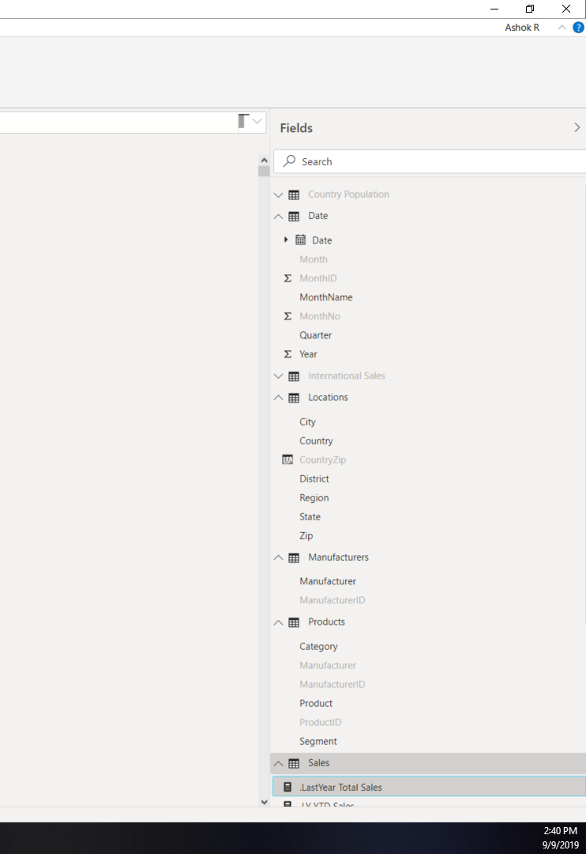

Different data columns have been make hidden at report level